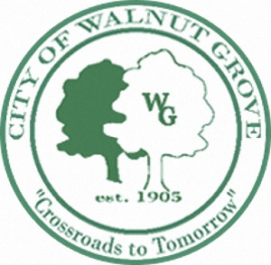
CITY OF WALNUT GROVE
June 12, 2023 - 7:00pm
1021 PARK STREET MUNICIPAL BUILDING
MAYOR AND COUNCIL

Council Called Meeting Agenda
- CALL TO ORDER
- INVOCATION
- PLEDGE OF ALLEGIANCE
- ROLL CALL
- AGENDA
- NEW BUSINESS
Budget Review
- ADJOURN

